Indices | Mathematics Stage 5.3

Summary of Substrands | Duration: 3 weeks
Indices MA4-9NA  Indices MA5.1-5NA  Indices MA 5.2-7NA | Start Date:
 | Completion Date:
 | Teacher and Class:
Outcomes
- MA5.3-1WM uses and interprets formal definitions and generalisations when explaining solutions and/or conjectures
- MA5.3-2WM generalises mathematical ideas and techniques to analyse and solve problems efficiently
- MA5.3-3WM uses deductive reasoning in presenting arguments and formal proofs
- MA5.3-6NA performs operations with surds and indices

Overview | Key Words | Suggested Assessment
Students work on simplifying more difficult algebraic expressions and use negative indices and zero indices. | Positive, negative, indices, index, base, exponent, reciprocal, surd rational, irrational, real numbers.  There is a need to emphasise to students how to read and articulate surds and fractional indices, eg$\sqrt{x}$ is the square root of x or root x | Test  Quick questions  Observations

Rego | Content | Teaching, learning and assessment | Resources
 | Stage 5.3 - Surds and Indices §  Students:  Define rational and irrational numbers and perform operations with surds and fractional indices (ACMNA264)  - define real numbers: a real number is any number that can be represented by a point on the number line  - define rational and irrational numbers: a rational number is any number that can be written as the ratio of two integers a and b where 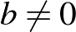; an irrational number is a real number that is not rational  - recognise that all rational and irrational numbers are real (Reasoning)  - explain why all integers, terminating decimals and recurring decimals are rational numbers (Communicating, Reasoning)  - explain why rational numbers can be expressed in decimal form (Communicating, Reasoning)  - use a pair of compasses and a straight edge to construct simple rational numbers and surds on the number line (Problem Solving)  - distinguish between rational and irrational numbers  - demonstrate that not all real numbers are rational (Problem Solving)  - use the term 'surd' to refer to irrational expressions of the form 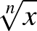 where is a rational number and is an integer such that 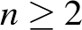  - write recurring decimals in fraction form using calculator and non-calculator methods,  eg 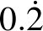, 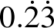, 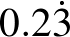  - justify why 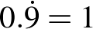 (Communicating, Reasoning)  - demonstrate that 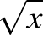 is undefined for x < 0 and that 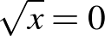 for x = 0  - define as the positive square root of x for x > 0  - use the following results for x > 0 and y > 0:  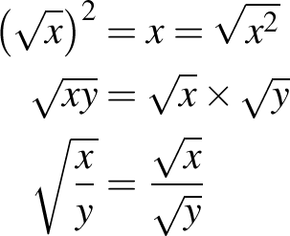  - apply the four operations of addition, subtraction, multiplication and division to simplify expressions involving surds  - explain why a particular sentence is incorrect, eg explain why 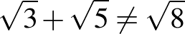 (Communicating, Reasoning)  - expand expressions involving surds, eg expand 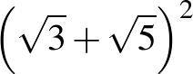, 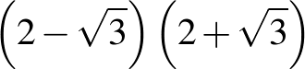  - connect operations with surds to algebraic techniques (Communicating)  - rationalise the denominators of surds of the form 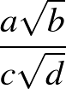  - investigate methods of rationalising surdic expressions with binomial denominators, making appropriate connections to algebraic techniques (Problem Solving)  - recognise that a surd is an exact value that can be approximated by a rounded decimal  - use surds to solve problems where a decimal answer is insufficient, eg find the exact perpendicular height of an equilateral triangle (Problem Solving)  establish that  - apply index laws to demonstrate the appropriateness of the definition of the fractional index representing the square root, eg  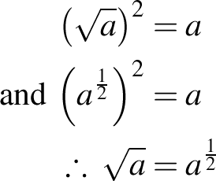  - explain why finding the square root of an expression is the same as raising the expression to the power of a half (Communicating, Reasoning)  - apply index laws to demonstrate the appropriateness of the following definitions for fractional indices: 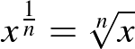, 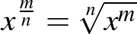  - translate expressions in surd form to expressions in index form and vice versa  - use the 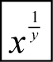 or equivalent key on a scientific calculator  evaluate numerical expressions involving fractional indices, eg 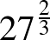 | Students review work from Stage 4 and 5.1 and 5.2 on index laws  Some History  The term surd traces back to al-Khwārizmī (c. 825), who referred to rational and irrational numbers as audible and inaudible, respectively. This later led to the Arabic asamm (deaf, dumb) for irrational number being translated as surdus (deaf or mute) into Latin. Gherardo of Cremona (c. 1150), Fibonacci (1202) and then Robert Recorde (1551) all used the term to refer to unresolved irrational roots [From wikipedia]  Introducing Surds  Remind students of exact answers when finding the length of sides using Pythagoras  Exact answers are needed in building  Revise Pythagoras so students have an understanding of exact values surds  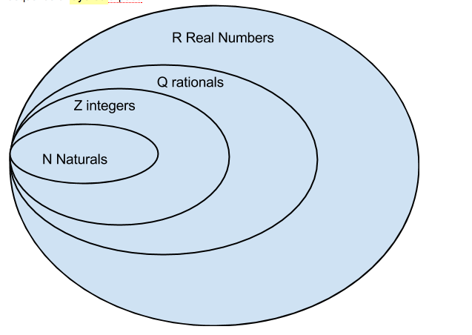  Students are given numbers and asked to place them on the layers  , 5, , 7 , , , 0. $\dot{3.}$  Explain rational and irrational numbers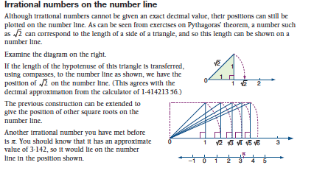l numbers  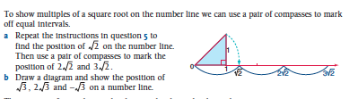  Watch video on recurring decimals in fraction form  Deliberate practice  Watch video why 0.9 = 1  Use calaculator and try to find the square root of negative numbers and discuss why it comes up with an error thus leading to the positive square root.  Use calculator to demonstrate and explain when you square a square root you get the integer  Deliberate practice  Simplify surds  Students write the first 12 square numbers and look for the square number in the surd to simplify  Adding and subtracting surds must have like surds relate it to algebra  Deliberate practice  Multiplying and dividing surds  Deliberate practice  Watch video rationalizing surds  Deliberate practice  Watch video on fractional indices  Fractional indices Practice changing from surds to fractional indices | Work sheet  Review Stage 4 and 5.1 with a work sheet or text book  Game to reinforce indices  http://www.bbc.co.uk/schools/gcsebitesize/maths/activities/flash/snap_powers/snap_powers.shtml  http://www.bbc.co.uk/schools/gcsebitesize/maths/number/powersroots/quiz/q89452185/  http://www.tes.co.uk/teaching-resource/Laws-of-Indices-Treasure-Hunt-KS3-GCSE-6068454/  http://www.youtube.com/watch?v=TGzIpq944Cc  http://www.youtube.com/watch?v=79Q08UYknTY  http://www.youtube.com/watch?v=79Q08UYknTY  http://www.youtube.com/watch?v=kCnba1bV4lE

Evaluation | Adjustment

